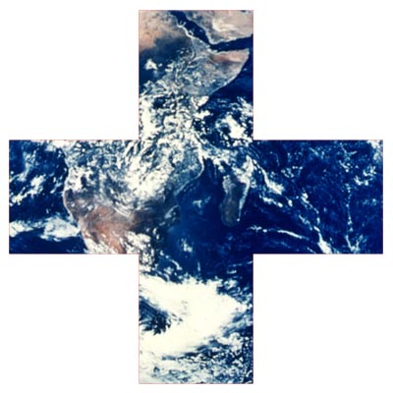
EWB

Email
To: | EWB Field Office Sebedoh | From: | Director of Field Ops
Re: | SEBEDOH SICKNESS | CC:
□ Urgent □ For Review □ Please Comment □ Please Reply □ Please Recycle

TIME: 1225 (Day 4)

Dear Colleagues,

We have heard some worrying rumours about a rare outbreak of a virus called ‘Sebedoh Sickness’. Please confirm the veracity of this rumour and if it is true, what plans you have in place to address the seriousness of this as a potential major public health issue.

I need not remind you that if the international media pick up on this there will be many questions being asked about our organisational response.

Kind regards, etc

From
Hendrika Van der Nacka
EWB Director of Field Ops

